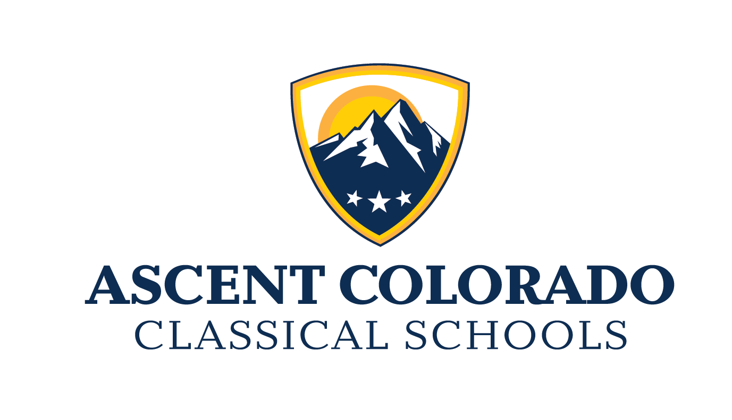

**BACKGROUND CHECK ACKNOWLEDGEMENT**

Ascent Classical Academy Charter Schools, Inc. “ACACS” requires that each employee undergoes a criminal background check by submitting fingerprints pursuant to 22-30.5-110.7 C.R.S. ACACS also requires volunteers who have direct contact with students during off site or after hour ACACS-sanctioned activities.

As such, you will be provided with information on how to go about making an appointment at a licensed fingerprinting location and have any questions answered about the fingerprinting procedure itself. Your fingerprints will be run through the criminal history databases of both the Federal Bureau of Investigation (FBI) and the Colorado Bureau of Investigation (CBI). Only security cleared ACACS HR staff will have access to the results. The hard copy results will be stored in a secure envelope in a locked cabinet, in a locked room in the Shard Services office in Golden. Your CBI/FBI files shall be securely destroyed upon separation from ACACS, in alignment with board policy.

You will not receive notification of the results of your background check unless there is a problem. Typically, we receive the results within 24 hours. In the event that a fingerprint-based background check produces adverse results, the individual in question shall:

* Have the opportunity to complete or challenge the accuracy of their results.
* Have the information on the process for updating, changing or correcting the results.
* Be afforded a reasonable time to correct or complete the background check.

The sole purpose of ACACS’s fingerprinting background check is to be in compliance with state and federal laws for the safety of the children in our care. ACACS will not share or disclose any information contained in the results of said background checks with any entity for any reason.

I,____________________________________________, hereby consent to the terms and conditions stated above.

___________________________________________________________________

Signature of Volunteer

______________________________

Date

**Once the Background Check Acknowledgement Form is completed, please scan and send to volunteers@ascentcolorado.org . Your information will be stored at the ACACS Shared Services location.**

**Finger Printing Instructions**

**Requirements for Applicants**

* Online Registration - Applicants visit<https://abi.cabiond.com/> (mobile and tablet friendly) to establish an account and register for an appointment.
* Order Details - The applicant enters your billing code and fingerprint details. Please select “CO Licensure/Employment CABS” when prompted from the drop down.
* Order ID - The applicant receives their order ID by email and by text message.
* Government Issued Photo ID - The applicant identifies himself/herself to the enrollment agent with a valid Govt. issued photo ID and the Order ID (email or text version). Livescan fingerprints, digital photo and digital signature are then captured and submitted to CBI.

**All campuses’ volunteers please use this billing code 8410ACACSVol when prompted.**